Assessing and mitigating the climate risk of urban heat- Challenges and prospects
C.Cartalis, A.Polydoros, I. Agathangelidis, K. Philippopoulos
Dept. of Environmental Physics, National and Kapodistrian University of Athens, ckartali@phys.uoa.gr
Abstract. Cities are vulnerable to excessive heat associated with climate change due to their high population density, infrastructure and built-up areas. Appropriate measures to mitigate urban heat need to consider the 'vibe' of the city as well as its urban functions, urban form and urban fabric. In the same framework, households with lower incomes are more exposed to heat, mainly due to the moderate or poor quality and age of the buildings, the higher density of heat sources in their vicinity. It is therefore necessary to prioritise the application of urban heat mitigation plans in these areas as well as to involve local communities in the urban heat mitigation process to raise awareness of climate change and to encourage local initiatives to increase equitable resilience. The paper examines the interlinkages between urban heat on the one hand and urban form, urban fabric and urban functions on the other, to define the measures need to mitigate urban heat. Examples of such measures will be presented and discussed accordingly.

1.Introduction

Cities are vulnerable to excessive heat associated with climate change due to their high population density, infrastructure, and built-up areas. In particular, the relationship between cities and climate change is multi-fold:

- An urban area is affected by climate change due to higher temperatures, the high temperature streaks and the increase of the intensity, duration and frequency of heatwaves.
- The increase of air temperature due to climate change is added to Urban Heat Island (UHI) phenomenon, namely the urban influence on local microclimates resulting in urban areas being warmer than the surrounding rural areas due to the lower vegetation cover, stronger absorption of solar radiation— because of the geometric structure of the city and the properties of surface materials—and anthropogenic heat sources such as buildings, industrial activities and car traffic. Overall, the UHI is generally stronger at night, as it is largely shaped by the slower cooling rate of urban areas compared to rural ones. On the other hand, the greatest heat burden and higher energy consumption in buildings for cooling occur during midday hours.
- The development of a city modifies land use and land cover, and consequently affects heat flows, evaporation rates, as well the spatial distribution and the intensity of anthropogenic heat sources.
- The urban morphology of an urban area significantly affects ventilation mechanisms and therefore either exacerbates or mitigates surface (air and land) temperature conditions.
2. Urban heat exposure
The variation in the intensity of anthropogenic heat sources within the urban fabric, combined with urban morphology and the increase in temperature due to climate change, determines the urban heat exposure of citizens. In Figure 1, urban heat exposure (vertical axis, Urban Heat Exposure Index – UHeatEx) is presented alongside household income in the wider urban area of Athens. Households with lower incomes experience greater heat exposure mainly due to the moderate or poor quality and the age of building constructions, the higher density of heat sources in their vicinity (e.g., major roads, industrial units, high building density), and/or the lack of green spaces.
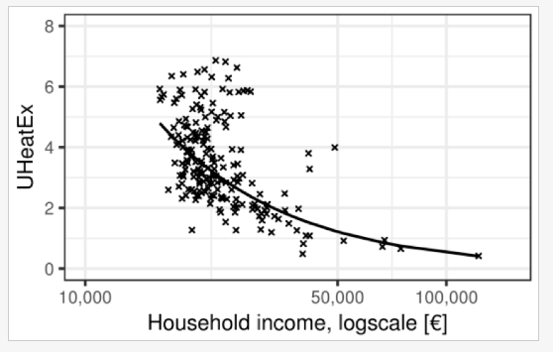

Figure 1. The relationship between the household income and the Urban Heat Exposure Index – (UheatEx) for Athens.
In Figure 2, the distribution of the Urban Heat Exposure Index for the wider urban area of Athens for the year 2019 is presented (higher values in red).
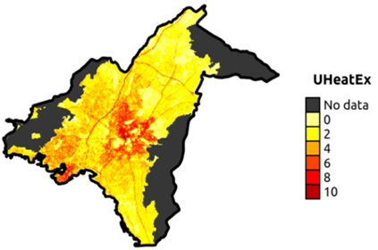

Figure 2. Distribution of the Urban Heat Exposure Index (UHeatEx) for the wider urban agglomeration of Athens for the year 2019.
The spatial distribution of the Urban Heat Exposure Index highlights the uneven distribution of heat in the city, a fact to be considered for just resilience. In particular, the highest values of the index are found in the centre of Athens and Piraeus where the driving forces of excessive urban heating obtain high values. High values are also observed in the western part of the urban agglomeration of Athens.
4. Urban morphology
Urban morphology significantly affects, especially in city streets, land surface temperature and consequently, because of heat transfer, air temperature close to the surface. Specifically, the higher the ratio of building height to street width, the higher the air temperature at the surface level especially at nighttime, due to the increased trapping of both the reflected solar radiation and the emitted thermal radiation by the ground, and the reduced wind speed at the ground. This negative impact becomes more pronounced during heatwaves and results in retaining heat in the built environment. In streets with these characteristics, it is necessary to reduce land surface temperatures, by increasing greenery, using cool materials at the surface and at the top of the buildings, removing heat sources such as vehicular traffic and converting them into pedestrian or low-traffic streets. In Figure 3, the distribution of streets in the centre of Athens is color-coded according to the height-to-width ratio (aspect ratio, H/W). Streets marked in orange and red are the highest priority for conversion, provided a comprehensive traffic study is conducted prior to any technical interventions. ΄

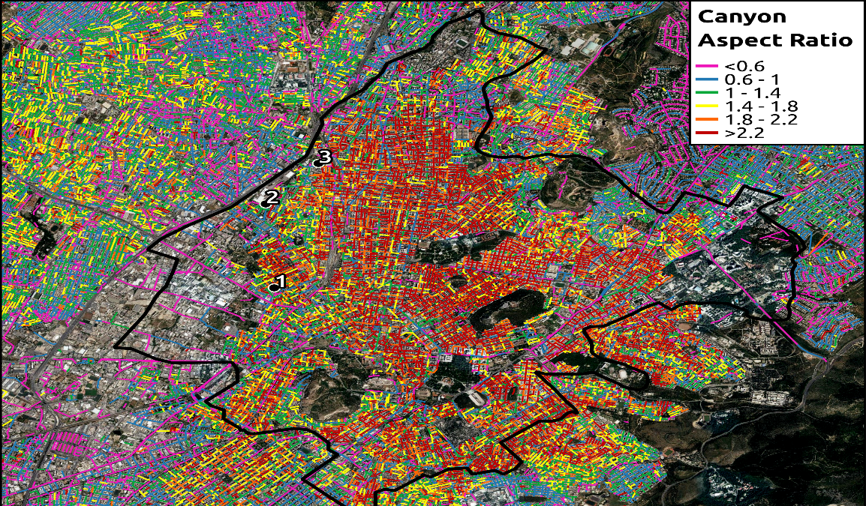

Figure 3. Distribution of streets in the centre of Athens according to the height-to-width ratio, termed as aspect ratio
5. Urban Fabric
The increased absorption of solar radiation by urban structures significantly contributes to the degradation of the urban thermal environment. Using natural or artificial materials with high reflectivity of solar radiation on building facades, roofs, and sidewalks in urban areas as an adaptation measure modifies radiation balance and air temperature in the city. A highly reflective surface absorbs less solar radiation, resulting in a lower surface temperature and, due to reduced heat transfer, also leads to a lower air temperature. Thus, an adaptation measure is the use of cool materials that can be applied to building envelopes as well as other surfaces in the urban built environment such as parking lots, sidewalks, and building exteriors to reduce temperature on these surfaces. In a simulation study in the Athens area during the summer period, it was found that increasing the reflectivity of the city's surface by 40% results in a reduction of air temperature at 2 meters above the ground surface by as much as 1.5 °C.
6. Urban Greenery
The use of greenery can significantly reduce heat in open spaces, as through reflection and absorption, trees can remove a large amount of incoming solar radiation. Practically, vegetation in open urban spaces offers shade and lower temperatures under the tree canopy compared to the surrounding area. Shaded surfaces, for example, can be 11 – 25 °C cooler than the maximum land surface temperatures of non-shaded materials. Another way vegetation can contribute to temperature reduction is through evapotranspiration, as the conversion of water from liquid to gas (water vapour) by vegetation lowers the temperature of both the foliage and the air. Evapotranspiration in combination with shading, can help reduce peak summer air temperatures by 1 – 5 °C. At the same time, the use of vegetation on roofs (green roofs) can also lead to a reduction in air temperature. Results show that the overall heat flow entering a building under a green roof is reduced compared to a conventional concrete roof without greenery, regardless of weather conditions.
An interesting research finding is that medium-sized parks can cool neighbouring areas with about the same intensity as larger parks. Figure 4 shows the correlation between the cooling effect of a park (SPCI: Surface Park Cooling Intensity) and parks with areas up to 16 hectares in the wider urban agglomeration of Athens. It is observed that the larger the area, the stronger the cooling effect of the park. However, when the correlation includes all parks regardless of size, it is observed that the cooling effect for parks larger than 16 hectares remains almost constant. This does not diminish the value of large green spaces but highlights the importance of dispersing small and medium-sized parks throughout the urban fabric (“urban acupuncture”) as part of adaptation plans for urban heat mitigation.

Figure 6. Correlation between the cooling effect of a park (SPCI: Surface Park Cooling Intensity) and the park’s area
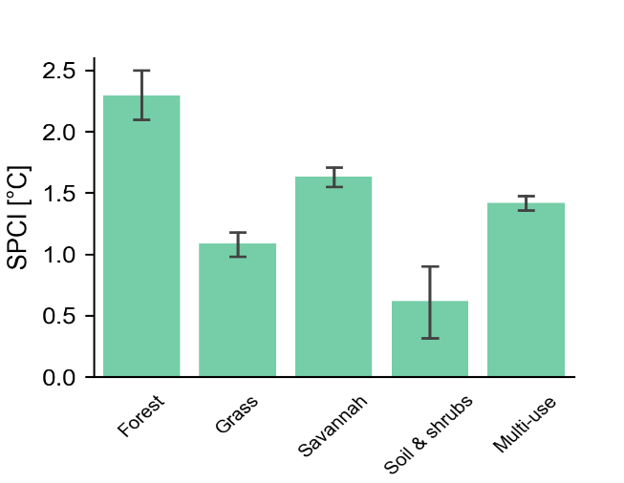
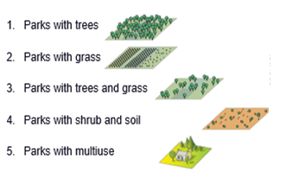
Another interesting finding is that under intense heatwave conditions, many plant species tend to close the stomata of their leaves due to severe heat stress, minimizing their cooling ability. This implies the need for the selection of the proper type of trees, to endure during high temperature streaks and heat waves. Figure 7 shows the variation of SPCI depending on the type of greeneryin a park.

Figure 5. Variation of SPCI (Surface Park Cooling Intensity) depending the type of greenery in parks
In cities with limited free spaces for creating parks, an alternative solution is converting schoolyards into a network of small parks. Such networks were developed in European cities such as Paris and Barcelona, to reduce air and land surface temperatures and, consequently, address excessive heat due to climate change, also through bioclimatic interventions in school buildings.
In a simulation experiment, a Primary School in Athens was examined in terms of its resilience to heat by applying a microclimatic model. The school's redesign (Figure 6) included planting in the courtyard, creating a small park at the back of the school building, installing a green roof, designing shade structures and a green wall on the western side of the school, and finally placing cool (reflective) materials in the schoolyard to reduce absorbed solar radiation and, consequently, land surface and overlying air temperatures. Simulations (at 12.00 pm) showed a decrease of air temperature from 1 to 3 °C in the school yard.
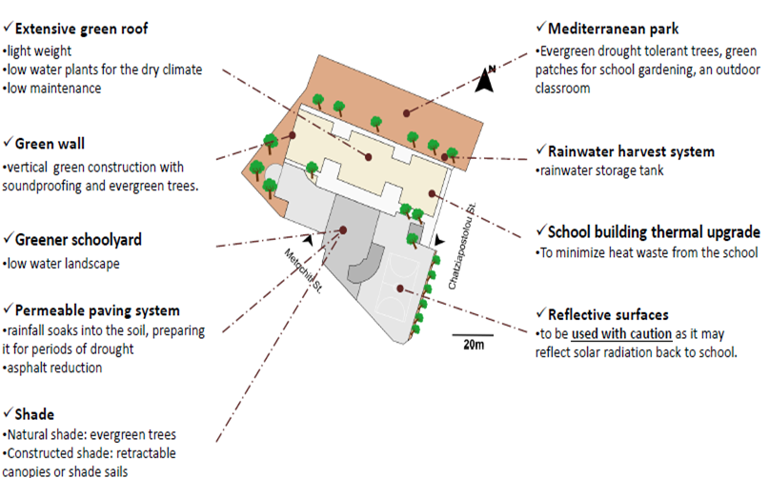

Figure 6. Elements of heat mitigation plan at the school level
An additional alternative solution is the one on super blocks, namely city blocks where vehicular traffic is restricted to the outer boundaries. The super blocks solution is being piloted in Barcelona in an effort to reclaim public space and, primarily, to enhance greenery in areas previously occupied by cars, thereby reducing air temperature and heat exposure. In practical terms, intersections are converted into green spaces, while only neighbourhood residents use the roads within the perimeter.
7. Blue Urbanism
The main impact of water surfaces on the urban heat lies in their ability to cool the air through evaporation. Additionally, the high heat capacity of water surfaces leads to lower temperatures. The heat capacity of water is about four times greater than the heat capacity of common building materials such as concrete, asphalt, granite, gravel, and marble. As a result, when absorbing the same amount of solar radiation, water exhibits a much smaller temperature increase than typical construction materials. Consequently, water surfaces can be considered heat sinks in urban spaces.

8. Concludions
- Each urban area needs its own heat mitigation plan. No urban heat mitigation plan can be indiscreetly applied anywhere.
- Set the institutional framework and ensure the involvement of stakeholders in its shaping.
- Conduct heat risk and vulnerability assessment at detailed spatial scale to differentiate the urban heat mitigation plan at the neighborhood scale.
- Engage the local communities in the urban heat mitigation process, raising awareness about climate change and urban heat, and fostering local initiatives to enhance just resilience.
- Develop a monitoring and evaluation system for the early assessment of the performance of the heat mitigation measures and
- Take note of the risk of maladaptation, namely when a heat mitigation plan instead of reducing vulnerability, creates new risks and negative consequences.
References
Agathangelidis, I., Cartalis, C., Santamouris, M. (2019): Integrating Urban Form, Function, and Energy Fluxes in a Heat Exposure Indicator in View of Intra-Urban Heat Island Assessment and Climate Change Adaptation, in: Climate 2019, 6 (7), 75. https://doi.org/10.3390/cli7060075
Agathangelidis, I., Blougouras, G., Cartalis, C., Polydoros, A., Mavrakou, T., and Tzanis, C.G. (2023): Surface thermal effects of parks in Mediterranean cities: an investigation under typical summer conditions, heatwaves and droughts. 2023 Joint Urban Remote Sensing Event (JURSE), IEEE. https://ieeexplore.ieee.org/document/10144132
Paravantis J., Santamouris M., Cartalis C., Efthymiou C., Kontoulis N. (2017): Mortality Associated with High Ambient Temperatures, Heatwaves, and the Urban Heat Island in Athens, Greece, in: Sustainability 2017, 9 (4), 606. https://doi.org/10.3390/su9040606

OASIS project, https://www.uia-initiative.eu/en/uia-cities/paris-call3
Climate Shelters project; https://www.uia-initiative.eu/en/uia-cities/barcelona-call3
114th Primary School at the Sepolia neighborhood

